King’s Spoke Planning

* Chosen turk’s head
  + <https://www.theknotsmanual.com/knots/turks-head-knot/#google_vignette>
  + Screenshot in third post

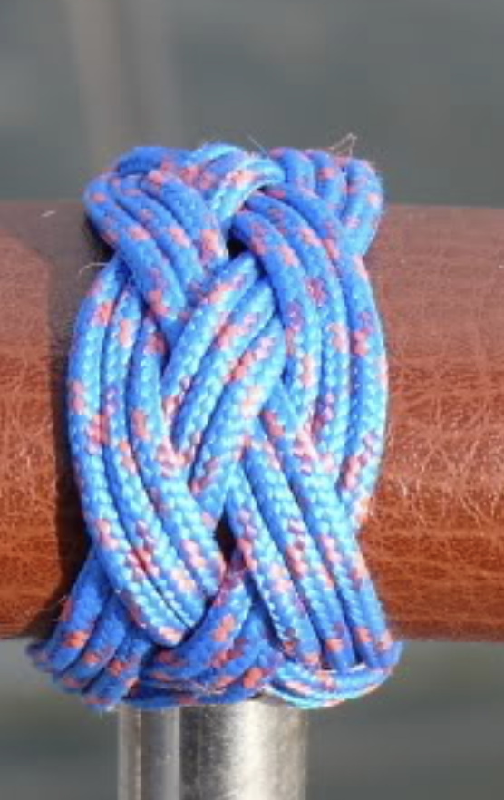

Day of: bring micro twine to tie standing end to wheel. Rope and tape and measuring tape so I can mark the middle and boundaries of the king’s spoke.

* Kit: Scissors, fabric napkin, lighter, permanent marker
* Paracord, mandrel
* <https://www.youtube.com/watch?v=SlqKtPWHAXk>